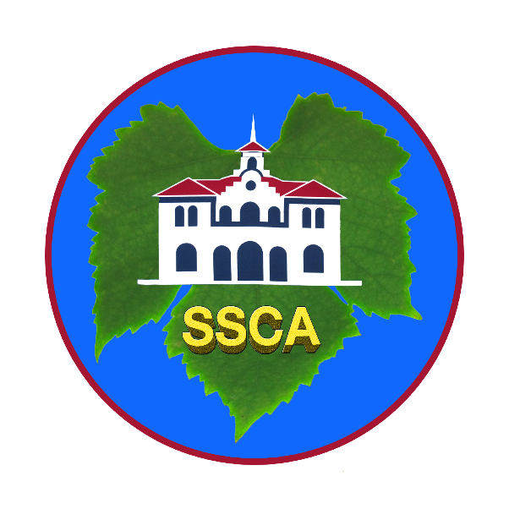
Sonoma Sister Cities Association (SSCA)

Promoting peace through mutual respect, understanding and cooperation –
one individual, one community at a time

APPLICATION FOR BOARD MEMBERSHIP

Name: ____________________________________________________________________

Phone: _________________________ Email: _____________________________________

Mailing Address: ____________________________________City__________ Zip________

Occupation and employer: _____________________________________________________

Why are you interested in joining our Board of Directors?

What personal skills or strengths would benefit our organization?

Is there a particular area of interest or committee that you would like to serve on?

What other volunteer commitments do you currently have?

Have you served on other nonprofit organization boards? If so, please list them and any offices you held:

The SSCA board meets every other month on the second Monday at 6 pm. Do you see any scheduling problems that might affect your attendance?

Visit our website www.sscasonoma.org to learn about SSCA programs and activities.

Return completed form to: president.sscasonoma@gmail.com
or mail to Sonoma Sister Cities Association, PO Box 1975, Sonoma, CA 95476

